**Exercise 1: Implementing the Singleton Pattern**

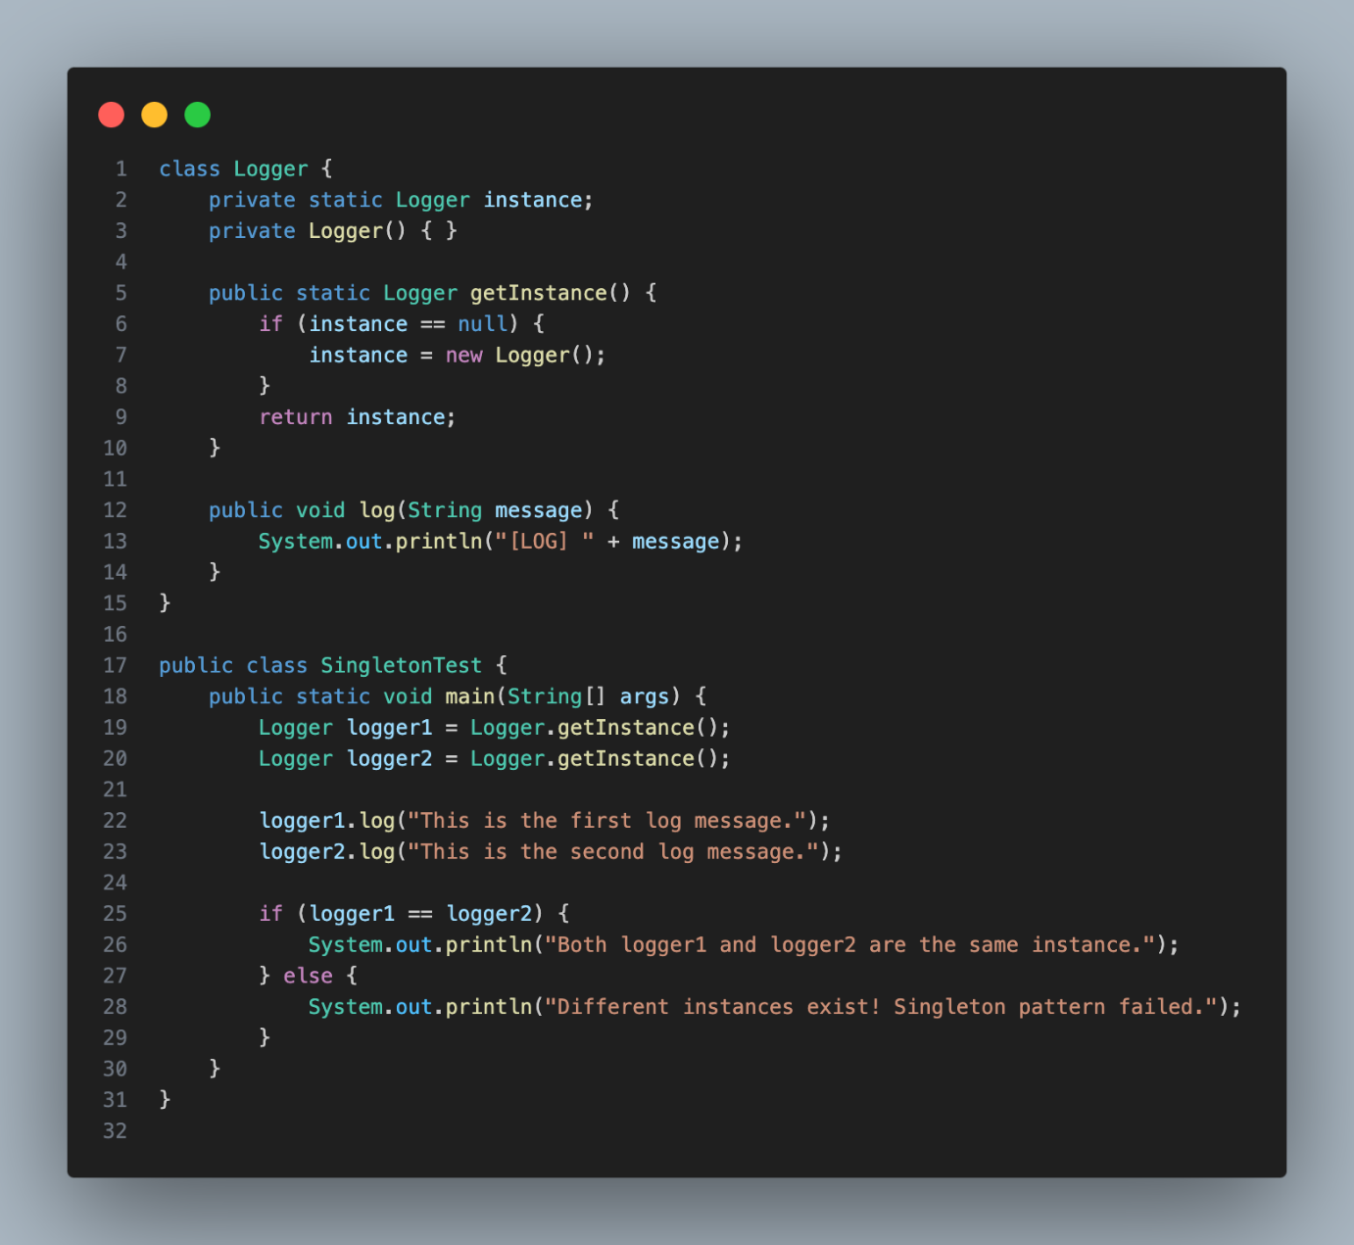

Output :

